

Gender Pay Gap Report 2024

November 2024

# Overview

### We have published our gender pay gap figures since 2018 in accordance with the statutory reporting regulations. We do so voluntarily as part of our commitment to equality and inclusion.

### The gender pay gap figures are based on the difference between the hourly rate of pay for males and females employed at full pay on 5 April 2024. The Society no longer pays performance awards; therefore, we will no longer report on the performance award gap.

### Understanding the gap

Gender pay gap figures fluctuate throughout the year. With an average of 170 employees, small changes in our workforce can have big impacts on our gender pay gap.

*In 2023, the gender split was the same, 31% males and 69% females.*

While the gender distribution has remained the same at 39% male and 61% female, the median average pay has moved due to turnover, with more females below the median average than before, resulting in the 2% increase.

It is important to note that the Society pays males and females equally for work of equal value. The gender gap is caused by our overall gender distribution. Females are represented across all quartiles, but there are more females than males at lower quartiles which have lower market salaries and therefore overall have a lower average salary than male employees. This creates an overall pay gap.

We prepared an Equal Pay Audit in addition to this Gender Pay Gap report which confirmed there is minimal difference between male and female average pay, with the exception of one outlier role affecting a specific job level average.

Historically, females have been underrepresented in our upper quartile, however over the last 4 years there has been a notable upwards trend signifying gender diversity progress at senior levels. This trend has continued, increasing from 47% to 49%.

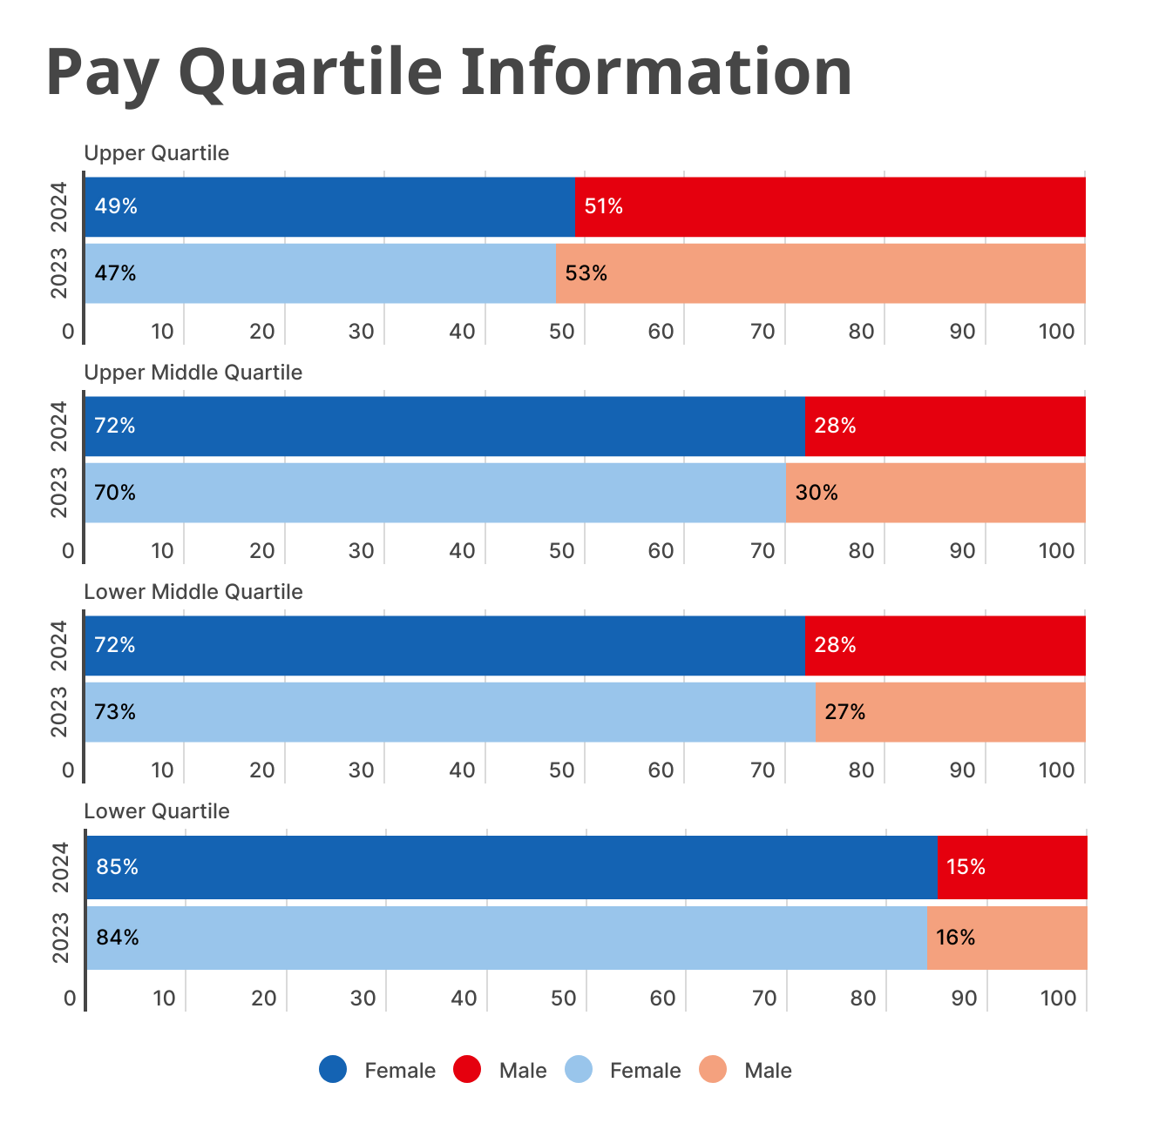

# Our ongoing work to address the gender pay gap

* We continue to work on a transparent ‘fair pay’ philosophy where employees are paid fairly for equal value work. Through our People Strategy, we are committed to further developing our pay practices. All salaries are benchmarked against external market data, and we continue to align all salaries internally.
* The Society uses an anonymised recruitment process, removing personal and defining details from applications to minimise unconscious bias. We continuously monitor our recruitment and selection processes to ensure we attract a diverse workforce, utilising specific diversity job boards to broaden our reach. We advertise vacancies with clear salary information and promote our flexible working culture, including hybrid arrangements. Our data indicates that we consistently attract, shortlist, and appoint women to more senior roles.
* We offer a comprehensive package of employment benefits, including learning and development initiatives for all employees. Our working arrangements reflect our commitment to inclusion and work-life balance, featuring a flex day scheme, generous holidays, hybrid working, and family-friendly policies like paid time off for dependents and carers leave.
* All roles can be considered for flexible working. This is supported by the fact that 42% of employees work flexible hours (up from 21% last year), 51% of females and 22% of males. This is across the organisation including executive and senior management.
* We have maintained our Leaders in Diversity accreditation from the National Centre for Diversity and are committed to achieving this level again when we are assessed in 2025. This represents the highest level an organisation can achieve and demonstrates our ongoing commitment towards equality, diversity and inclusion in the workplace.

# Our commitment to tackling our gender pay gap

The Society has already taken several steps to support an inclusive and diverse workforce, and we are committed to further enhancing our role as a fair and transparent employer. We are pleased to see positive trends, particularly the increase in female representation in our upper quartile.

We will continue to strengthen our efforts in promoting equality and diversity in the workplace, ensuring that we explore, and address issues related to the gender pay gap. Our senior leadership team is dedicated to supporting ongoing initiatives to promote gender equality, guided by the recommendations from our National Centre for Diversity accreditation. This aligns with our People Strategy, where diversity, equality, and inclusion are key themes. We are committed to delivering on our 5-year strategy, fostering an environment where everyone can thrive.

# Declaration

We confirm that our gender pay calculations are accurate and meet the requirements of the regulations.

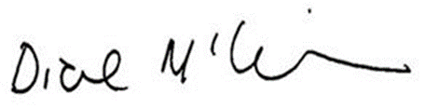

**Diane McGiffen  
Chief Executive**