THE LAW SOCIETY OF SCOTLAND
QUALIFIED LAWYERS ASSESSMENT
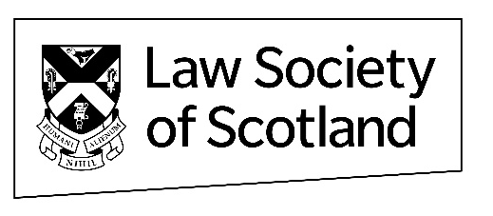
APPLICATION FOR EXAM ENROLMENT

(All questions to be answered)
Full name and address
Telephone number
Email address
Date of admission as solicitor
Professional title
(e.g. Avocat, Rechtsanwalt)
Home Bar Association

Some candidates may require adjustments to the exam procedures to ensure the fairness of the assessment. If required, please state clearly the nature of the adjustment, the reasons for it, and provide evidence to support your application (please indicate on a separate piece of paper and submit with enrolment form, fees and relevant enclosures).

I wish to be enrolled in below exam(s) at the diet held in; ( May ) ( November )
*input (x) in relevant box(es)*

Legal system and legal method |  |  | Conveyancing
Public Law |  |  | Trusts and Succession
Obligations |  |  | European Law and Institutions
Criminal Law |  |  | Professional Conduct
Evidence |  |  | The Accounts Rules
Procedure

Exam enrolment fee is £110 per exam. The Society will provide payment instructions once your enrolment form has been received.

Please return to the form to louisebradley@lawscot.org.uk

Disclaimer

Candidates must answer the exam on their own and must not confer with other candidates undertaking the same examination. In principle, your answers should be as they would be in an exam hall.

Exam answers must be a candidate’s own, individual, original work. Where a candidate chooses to quote an authority or source, or believes that they are required to do so in order to answer a question:
- the quote must be suitably acknowledged in the exam script by placing it in quotation marks, citing the author’s name and stating the source (e.g. text or website);
- the answer must not consist solely or substantively of a quote or quotes; and
- the answer should expand on the quote, in the candidate’s own words.

Candidates are advised that direct copying of the text of materials into their exam script (other than as noted above or brief parts of primary sources, where precise technical wording is required) is likely to attract no marks and, if not appropriately referenced, may amount to plagiarism. A candidate who enables another candidate to plagiarise, copy or cheat will be subject to the same penalty.

Examiners will be checking for plagiarism and for any indication of collusion or of assistance from others. In marking, examiners will recognise:
- the novelty of these remote exam arrangements for candidates and the possible difficulties presented;
- the fact that candidates can access other materials in preparing their answers.

Artificial Intelligence (AI) platforms

Candidates will be aware of AI-platforms that can potentially be used in research and essay-writing and consequently may be tempted to use this for assessments or to submit an exam answer(s) that does not reflect their own learning.

Use of AI-generated content is not permitted for Law Society of Scotland exams. This means that you must not submit an AI answer to a question or use AI as research in order to answer your question(s). Even if appropriately flagged, the Society would view the use of AI-generated content to answer any part of an assessment or exam question as akin to dishonest behaviour or cheating.

Fitness and Properness to be a Solicitor

Candidates are also reminded that the Society’s Fitness & Properness Guidance outlines dishonesty and deception (including plagiarism, collusion, ghostwriting or other form of cheating in any form of assessment) as a matter which causes it serious concern. For candidates who are found to be guilty of any of these behaviours, this may later be grounds for determining that you are not a fit and proper person to be admitted as a Scottish solicitor, irrespective of any individual or collective exam results.

Declaration - I hereby declare that the answers provided at each exam will be my own work.

SIGNATURE:_______________________________ DATE: __________________

